WEEK 4 TASK
Performance, Accessibility &
Security Audit
E-Governance Digital Service — SevaSetu
Performance Metrics • WCAG Review • Security Risks • Recommendations
Prepared for internship submission
2 September 2026

1. Executive Summary
This audit evaluates the hypothetical SevaSetu e-governance digital service platform across performance, accessibility and security. The review focuses on page loading, responsiveness, resource usage, WCAG-oriented accessibility practices, and common web application risks including cross-site scripting, injection, broken access control and insecure file handling.
Because this is a design-stage/hypothetical audit rather than a live production measurement, the numeric results in the charts are illustrative. They demonstrate how findings should be documented and compared with targets. Before release, the same measurements should be collected from the implemented staging environment and replaced with real evidence.

2. Audit Scope & Methodology
- Review the citizen journey: Home → Service Search → Authentication → Application Form → Document Upload → Review/Submit → Application Tracking.
- Inspect desktop, tablet and mobile viewport behavior.
- Use browser developer tools and Lighthouse/PageSpeed-style measurements for performance.
- Use keyboard-only navigation, zoom/reflow checks, automated accessibility scans and manual screen-reader checks.
- Use authorized staging-only security testing, code/configuration review and dependency checks.
- Classify findings by severity, impact, likelihood and remediation effort.

3. Performance Evaluation

3.1 Key Performance Indicators
KPI | Measures | Recommended target
Largest Contentful Paint (LCP) | Main content rendering speed | ≤ 2.5 s
First Contentful Paint (FCP) | First meaningful visual render | ≤ 1.8 s target
Interaction to Next Paint (INP) | Interaction responsiveness | ≤ 200 ms
Cumulative Layout Shift (CLS) | Unexpected layout movement | ≤ 0.10
Total Blocking Time (TBT) | Main-thread blocking in lab tests | Keep below ~200 ms where practical
Page weight | Transferred images/scripts/fonts | Minimize and set a project budget
API response time | Backend request responsiveness | Set endpoint-specific limits
Error rate | Failed requests/submissions | Near-zero for core transactions

3.2 Illustrative Audit Findings
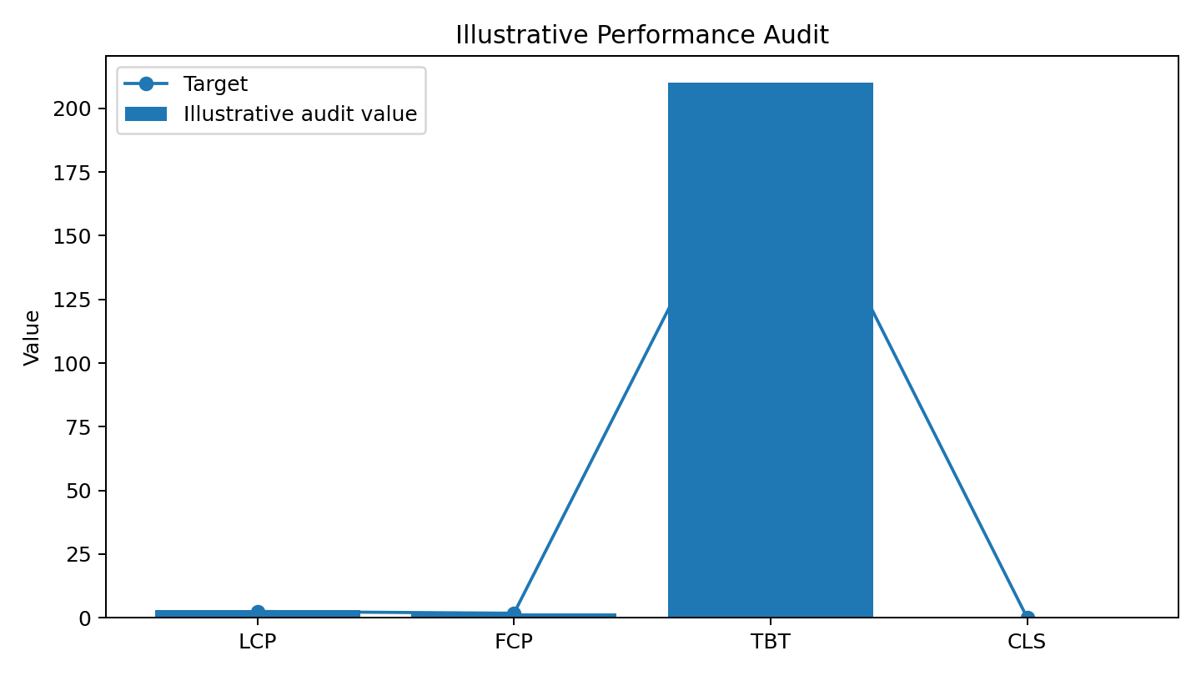
Figure 1. Illustrative performance results; these are not measurements from a live deployment.
Finding | Illustrative observation | Priority
LCP | 2.9 s, above the 2.5 s target. | High
FCP | 1.8 s, at the stated target. | Monitor
TBT | 210 ms, slightly above the example target. | Medium
CLS | 0.12, above the 0.10 target. | Medium

3.3 Performance Recommendations
- Compress and correctly size images; use modern formats and responsive image sizes.
- Defer non-critical JavaScript/CSS and reduce unused code.
- Reserve dimensions for images and dynamic components to reduce layout shifts.
- Use caching for static assets and reduce unnecessary network requests.
- Optimize API/database queries and avoid duplicate requests during form navigation.
- Lazy-load below-the-fold content where appropriate.
- Test slower mobile networks and lower-powered devices.
- Set performance budgets and monitor regressions during development.

4. Accessibility Assessment
The accessibility review follows WCAG-oriented principles: information should be perceivable, operable, understandable and robust. Priority areas for a citizen-facing service include keyboard access, visible focus, readable contrast, semantic structure, accessible forms, meaningful errors, text alternatives, zoom/reflow and assistive-technology compatibility.
Area | Audit check | Target
Keyboard | All controls reachable and operable without a mouse. | 100% critical journey
Focus | Visible focus and logical tab order. | Pass
Contrast | Text and important states remain distinguishable. | WCAG AA
Forms | Labels, required indicators, instructions and errors. | All critical fields
Screen reader | Headings, landmarks, names, states and errors. | Critical journey usable
Zoom/reflow | Content remains usable without avoidable horizontal scrolling. | Pass
Images | Meaningful images have text alternatives. | 100% meaningful images
Motion | No essential information depends on animation. | Pass

4.1 Illustrative Accessibility Results
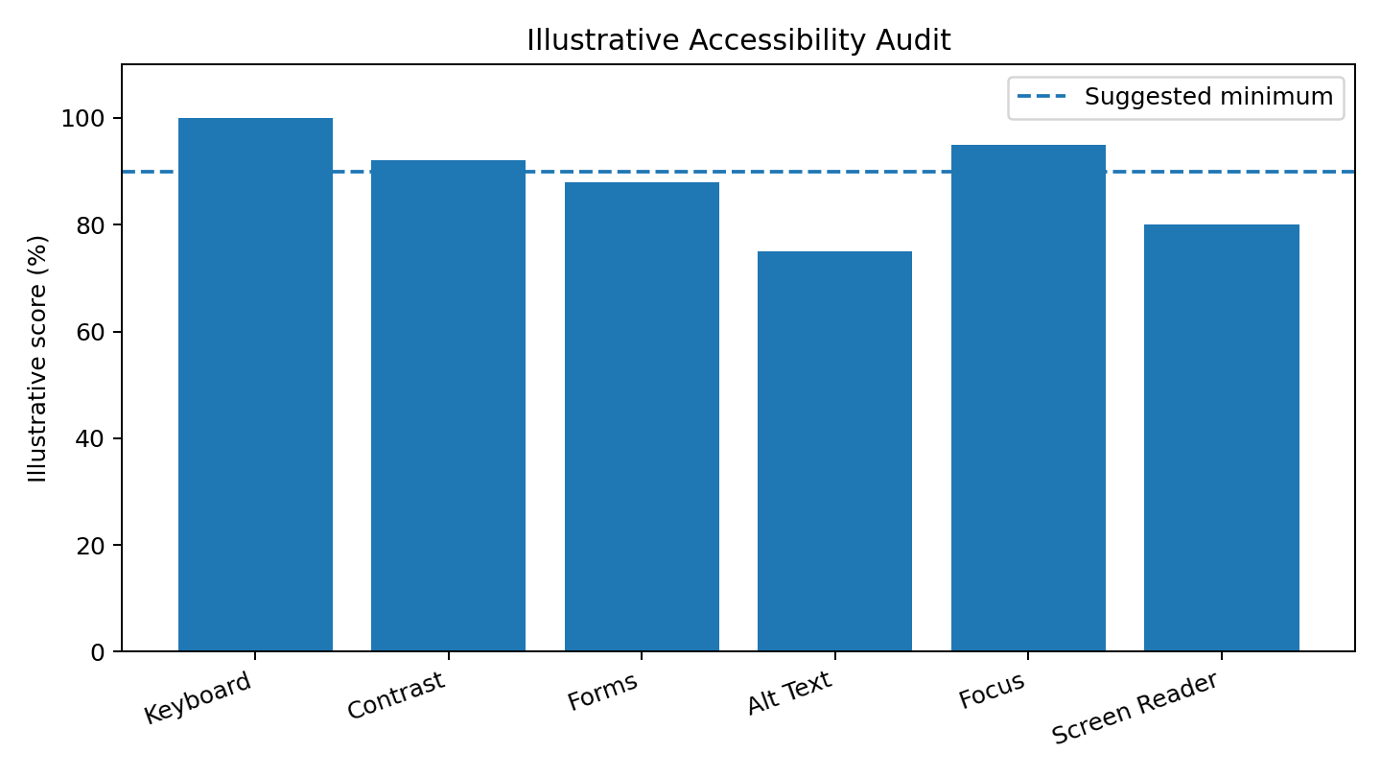
Figure 2. Illustrative accessibility scoring for audit demonstration; replace with actual test evidence after implementation.
Issue | Impact | Recommendation | Priority
Incomplete alt text | Screen-reader users may miss information. | Add meaningful alternatives or mark decorative images correctly. | High
Form semantics | Assistive-technology users may not understand fields/errors. | Programmatically associate labels, descriptions and errors. | High
Contrast | Secondary text may be difficult to read. | Verify color combinations against WCAG AA. | Medium
Focus management | Dialogs/errors may not receive focus predictably. | Manage focus when dialogs open and after validation. | High
Screen-reader coverage | Automated scans cannot find every usability issue. | Perform manual testing on the core journey. | Medium

5. Security Analysis
Security testing should be performed only against authorized development/staging environments. The audit concentrates on defensive identification of common weaknesses that could expose citizen information or compromise service integrity.
Risk | Potential impact | Recommended control | Severity
Cross-Site Scripting (XSS) | Malicious script may execute in a user's browser. | Context-aware output encoding, safe templates, validation and appropriate CSP. | High
SQL injection | Input could manipulate queries or expose records. | Parameterized queries/prepared statements and least-privilege DB access. | Critical
Broken access control | A user could access another citizen's application. | Server-side authorization on every protected request; test object-level access. | Critical
Insecure file upload | Unexpected/malicious files could compromise storage/application. | Allowlist types, size limits, content validation, safe names and isolated storage. | Critical
Session weaknesses | Account/session information could be exposed. | HTTPS, secure cookies, expiry, rotation and logout invalidation. | High
Sensitive data exposure | Personal data could leak through errors/logs/responses. | Minimize, redact and restrict sensitive information. | High
CSRF | Unauthorized state-changing actions may be triggered. | SameSite cookies and anti-CSRF protections where applicable. | High
Outdated dependencies | Known vulnerabilities may enter through libraries. | Dependency inventory, scanning and timely updates. | Medium/High

6. Security Hardening Priorities
- Enforce HTTPS for deployed service traffic.
- Apply server-side authorization and least-privilege access.
- Use parameterized database queries.
- Apply output encoding and safe templating.
- Secure session and cookie configuration.
- Treat uploaded documents as untrusted input and isolate them from executable paths.
- Keep secrets out of source code.
- Redact passwords, tokens and unnecessary personal information from logs.
- Scan dependencies and configurations regularly.
- Maintain an incident-response and recovery procedure.

7. Prioritized Improvement Roadmap
Priority | Action | Area | Timing
P0 | Fix authorization, injection and unsafe upload weaknesses before release. | Security | Before release
P0 | Protect authentication/session handling and sensitive data. | Security | Before release
P1 | Reduce LCP/JavaScript blocking and improve API responsiveness. | Performance | Next sprint
P1 | Fix form semantics, focus management and screen-reader issues. | Accessibility | Next sprint
P1 | Add automated accessibility, performance and security checks to CI. | All | Next sprint
P2 | Optimize images, caching and non-critical assets. | Performance | Following sprint
P2 | Expand browser/device and assistive-technology coverage. | Accessibility | Following sprint
P3 | Establish recurring audits and performance budgets. | All | Ongoing

8. Risk Mitigation & Contingency
Risk | Mitigation | Contingency
Performance regression | Budgets, monitoring and release checks. | Rollback affected release and investigate.
Critical security finding | Block release and patch in staging. | Disable affected feature and follow incident response.
Accessibility defect blocks a journey | Manual assistive-tech testing and acceptance criteria. | Provide accessible alternative while fixing.
Monitoring misses failures | Centralized logs, alerts and synthetic checks. | Escalate incident and perform manual verification.
Third-party vulnerability | Dependency inventory and scanning. | Upgrade, replace or isolate component.

9. Audit Evidence to Collect
- Performance: reports, network waterfall, device/network profile and before/after measurements.
- Accessibility: scan results, keyboard checklist, screenshots and screen-reader notes.
- Security: authorized scan findings, dependency report, configuration review and remediation evidence.
- Defects: issue ID, severity, reproduction steps, owner, fix version and retest result.
- Release record: audit date, build/version, environment and accepted known issues.

10. Conclusion
The SevaSetu audit demonstrates that performance, accessibility and security should be evaluated together. Fast pages improve completion, accessible interactions help more citizens use services independently, and strong security controls protect trust and information. The highest priorities are protecting authorization, data handling and file uploads while improving critical loading/interaction performance and resolving accessibility issues in forms and focus management.

Appendix — Audit Status Template
Audit item | Status | Evidence / notes
Performance KPI collection | Replace with live results | Record environment and date.
WCAG-oriented manual review | Planned | Record keyboard, zoom and screen-reader results.
Automated accessibility scan | Planned | Attach scan and remediation list.
Security review | Planned | Run only in authorized staging.
Remediation verification | After fixes | Retest P0/P1 findings before release.

